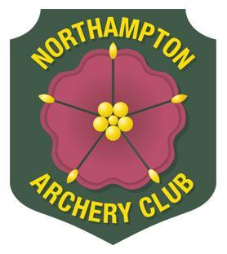
Northampton Archery Club
Annual General Meeting 2020
TBC 2020 at TBC at
TBC

PROPOSAL FORM

Proposal :

Proposer :(this can be changed at the meeting if someone else proposes the motion and the initial proposer is not present)

Seconder : (this may be left blank but the motion must be seconded at the AGM)

Background, Information and Discussion Details

About the vote (any special information considered necessary regarding the voting)

All proposal forms must be returned to the Secretary either by email, or by hand:
secretary@northamptonarchery.co.uk

Please return no later than 2 weeks before the AGM in order that the proposals can be circulated and considered by the membership prior to the meeting.

