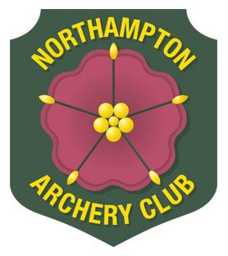
Northampton Archery Club

Club Record Score Claim Form

Name of Archer
Age (if junior)
ArcheryGB Number
Tel. No.
E-mail
Category | Lady – Gent / Senior – Junior  Recurve – Compound – Barebow – Longbow - Flatbow
Round Shot
Date
Venue
Name of Event
Score Claimed |  | Current record  (if known)
Web-link location for results (if known). | This box may only be used for claims submitted via e-mail,, where the link can be opened via a web-browser.
Is this score a new county record?
Signature
Date

When you submit your details to Northampton Archery Club for your claim, we will process your information under a Legitimate Interest and for the purposes of processing your claim only. We will keep your information for periods of time as set out in our privacy policy available on our website. Your information will be shared with relevant members of the committee.

All record claims must be accompanied by either (or both):
- The original score sheet (or copy of), which clearly states the date, the round, the score, the venue and the tournament.
- A copy of the tournament results sheet, which clearly states the date, the round, the score, the venue and the tournament.
- None of the above are required if a web-link to the results is shown in the appropriate box.
Claims should be sent to the Club Records Officer – records@northamptonarchery.co.uk

Revised 3rd April 2018

